- LINKED LIST
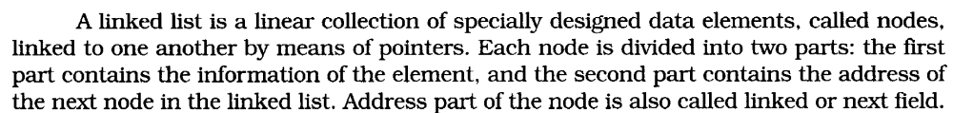

Following Figure shows a typical example of node
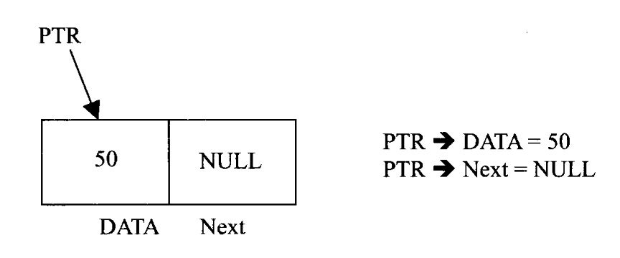

Node

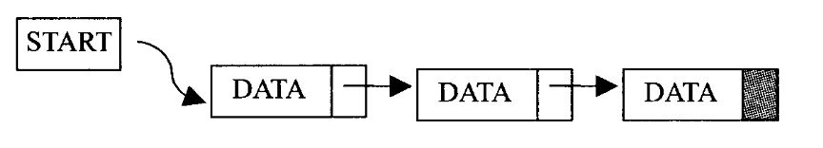

Linked List

Above Figure shows a schematic diagram of a linked list with 3 nodes. Each node is pictured with two parts. The left part of each node contains the data items and the right part represents the address of the next node; there is an arrow drawn from it to the next node. The next pointer of the last node contains a special value, called the NULL pointer, which does not point to any address of the node. That is NULL pointer indicates the end of the linked list. START pointer will hold the address of the 1st node in the list START = NULL if there is no list (i.e.; NULL list or empty list).

- REPRESENTATION OF LINKED LIST

Suppose we want to store a list of integer numbers using linked list. Then it can be schematically represented as follow

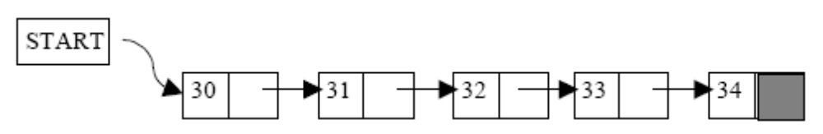

Linked list representation of integers
The linear linked list can be represented in memory with the following declaration.

struct Node
{
int DATA; //Instead of ‘DATA’ we also use ‘Info’
struct Node *Next; //Instead of ‘Next’ we also use ‘Link’
};

struct Node *NODE;

- ADVANTAGES AND DISADVANTAGES

Linked list have many advantages and some of them are:
1. Linked list are dynamic data structure. That is, they can grow or shrink during the execution of a program.

2. Efficient memory utilization: In linked list (or dynamic) representation, memory is not pre-allocated. Memory is allocated whenever it is required. And it is deallocated (or removed) when it is not needed.

3. Insertion and deletion are easier and efficient. Linked list provides flexibility in inserting a data item at a specified position and deletion of a data item from the given position.

4. Many complex applications can be easily carried out with linked list.

Linked list has following disadvantages

1. More memory: to store an integer number, a node with integer data and address field is allocated. That is more memory space is needed.

2. Access to an arbitrary data item is little bit cumbersome and also time consuming.

- OPERATION ON LINKED LIST
The primitive operations performed on the linked list are as follows

1. Creation
2. Insertion
3. Deletion
4. Traversing
5. Searching
6. Concatenation

Creation operation is used to create a linked list. Once a linked list is created with one node, insertion operation can be used to add more elements in a node.
Insertion operation is used to insert a new node at any specified location in the linked list. A new node may be inserted.

(a) At the beginning of the linked list
(b) At the end of the linked list
(c) At any specified position in between in a linked list

Deletion operation is used to delete an item (or node) from the linked list. A node may be deleted from the

(a) Beginning of a linked list
(b) End of a linked list
(c) Specified location of the linked list

Traversing is the process of going through all the nodes from one end to another end of a linked list. In a singly linked list we can visit from left to right, forward traversing, nodes only. But in doubly linked list forward and backward traversing is possible.

Concatenation is the process of appending the second list to the end of the first list. Consider a list A having n nodes and B with m nodes. Then the operation concatenation will place the 1st node of B in the (n+1)th node in A. After concatenation A will contain (n+m) nodes

- TYPES OF LINKED LIST

Basically we can divide the linked list into the following three types in the order in which they (or node) are arranged.

1. Singly linked list
2. Doubly linked list
3. Circular linked list

- SINGLY LINKED LIST

All the nodes in a singly linked list are arranged sequentially by linking with a pointer. A singly linked list can grow or shrink, because it is a dynamic data structure. Following figure explains the different operations on a singly linked list.
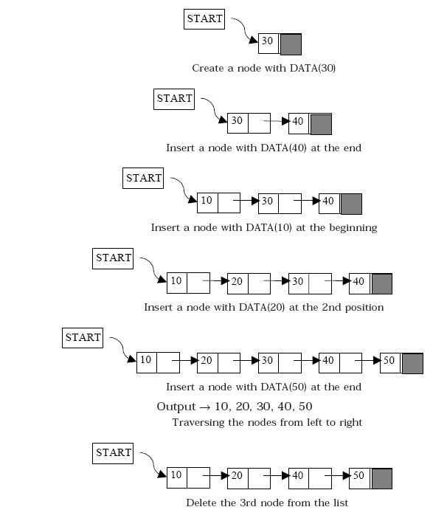

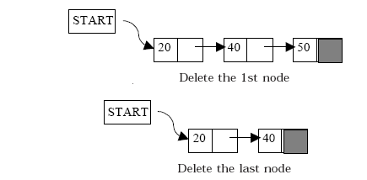

- ALGORITHM FOR INSERTING A NODE
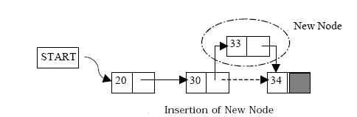

Suppose START is the first position in linked list. Let DATA be the element to be inserted in the new node. POS is the position where the new node is to be inserted. TEMP is a temporary pointer to hold the node address.

- Insert a Node at the beginning

1. Input DATA to be inserted
2. Create a NewNode
i.e. NewNode=( struct node * ) malloc ( sizeof ( struct node ) )
3. If NewNode is null then
Print “ Memory is insufficient “
Exit
Otherwise goto 4.
4. NewNode → DATA = DATA
5. If (SATRT equal to NULL)
(a) NewNode → Link = NULL
Otherwise
(a) NewNode → Link = START
6. START = NewNode
7. Exit

- Insert a Node at the end

1. Input DATA to be inserted
2. Create a NewNode
i.e. NewNode=( struct node * ) malloc ( sizeof ( struct node ) )
3. If NewNode is null then
Print “ Memory is insufficient “
Exit
Otherwise goto 4.
4. NewNode → DATA = DATA
5. NewNode → Next = NULL
6. If (SATRT equal to NULL)
(a) START = NewNode
Otherwise
(a) TEMP = START
(b) While (TEMP → Next not equal to NULL)
(i) TEMP = TEMP → Next
7. TEMP → Next = NewNode
8. Exit

- Insert a Node at any specified position

1. Input DATA and POS to be inserted
2. intialise TEMP = START; and j = 0
3. Repeat the step 3 while( k is less than POS)
(a) TEMP = TEMP → Next
(b) If (TEMP is equal to NULL)
(i) Display “Node in the list less than the position”
(ii) Exit
(c) k = k + 1
4. Create a NewNode
i.e. NewNode=( struct node * ) malloc ( sizeof ( struct node ) )
5. If NewNode is null then
Print “ Memory is insufficient “
Exit
Otherwise goto 6.
6. NewNode → DATA = DATA
7. NewNode → Next = TEMP → Next
8. TEMP → Next = NewNode
9. Exit

- ALGORITHM FOR DELETING A NODE
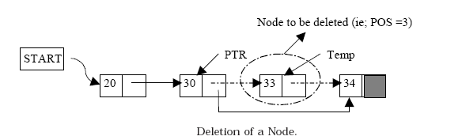

Suppose START is the first position in linked list. Let DATA be the element to be deleted. TEMP, HOLD is a temporary pointer to hold the node address.

1. Input the DATA to be deleted
2. if ((START → DATA) is equal to DATA)
(a) TEMP = START
(b) START = START → Next
(c) Set free the node TEMP, which is deleted
(d) Exit
3. HOLD = START
4. while ((HOLD → Next → Next) not equal to NULL))
(a) if ((HOLD → NEXT → DATA) equal to DATA)
(i) TEMP = HOLD → Next
(ii) HOLD → Next = TEMP → Next
(iii) Set free the node TEMP, which is deleted
(iv) Exit
(b) HOLD = HOLD → Next
5. if ((HOLD → next → DATA) == DATA)
(a) TEMP = HOLD → Next
(b) Set free the node TEMP, which is deleted
(c) HOLD → Next = NULL
(d) Exit
6. Disply “DATA not found”
7. Exit

- ALGORITHM FOR SEARCHING A NODE

Suppose START is the address of the first node in the linked list and DATA is the information to be searched. After searching, if the DATA is found, POS will contain the corresponding position in the list.

1. Input the DATA to be searched
2. Initialize TEMP = START; POS =1;
3. Repeat the step 4, 5 and 6 until (TEMP is equal to NULL)
4. If (TEMP → DATA is equal to DATA)
(a) Display “The data is found at POS”
(b) Exit
5. TEMP = TEMP → Next
6. POS = POS+1
7. If (TEMP is equal to NULL)
(a) Display “The data is not found in the list”
8. Exit

- ALGORITHM FOR DISPLAY ALL NODES

Suppose START is the address of the first node in the linked list. Following algorithm will visit all nodes from the START node to the end.

1. If (START is equal to NULL)
(a) Display “The list is Empty”
(b) Exit
2. Initialize TEMP = START
3. Repeat the step 4 and 5 until (TEMP == NULL )
4. Display “TEMP → DATA”
5. TEMP = TEMP → Next
6. Exit

- DOUBLY LINKED LIST

A doubly linked list is one in which all nodes are linked together by multiple links which help in accessing both the successor (next) and predecessor (previous) node for any arbitrary node within the list. Every nodes in the doubly linked list has three fields: LeftPointer, RightPointer and DATA. Following Figure shows a typical doubly linked list.

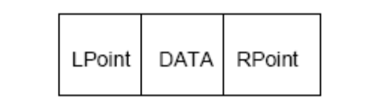

A typical doubly linked list.

LPoint will point to the node in the left side (or previous node) that is LPoint will hold the address of the previous node. RPoint will point to the node in the right side (or next node) that is RPoint will hold the address of the next node. DATA will store the information of the node.

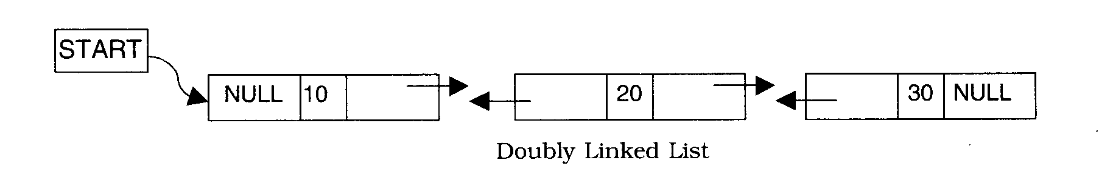

- REPRESENTATION OF DOUBLY LINKED LIST

Suppose we want to store a list of integer numbers using linked list. Then it can be schematically represented as follow

The linear linked list can be represented in memory with the following declaration.

struct Node
{
int DATA; //Instead of ‘DATA’ we also use ‘Info’
struct Node *RChild; //Instead of ‘RChild’ we also use ‘Previous’
struct Node *LChild; //Instead of ‘LChild’ we also use ‘Next’
};
struct Node *NODE;

All the operation performed on singly linked list can also be performed on doubly linked list. Following figures illustrate the insertion and deletion of nodes in a doubly linked list.
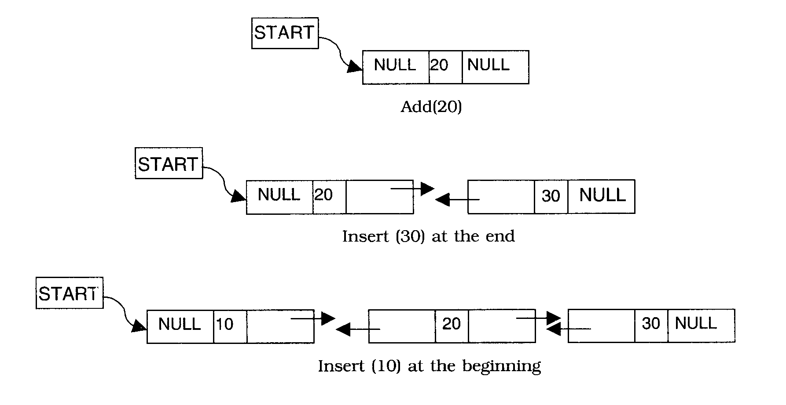

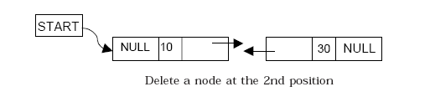

- ALGORITHM FOR INSERTING A NODE INTO A DOUBLY LINKED LIST
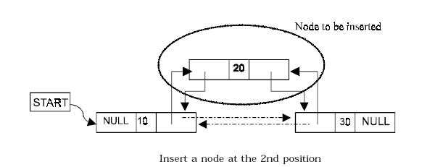

Suppose START is the first position in linked list. Let DATA be the element to be inserted in the new node. POS is the position where the NewNode is to be inserted. TEMP and TEMPPREV is a temporary pointer to hold the node address.

1. Input the DATA and POS
2. Initialize TEMP = START; i = 1
3. Repeat the step 4 if (i less than POS) and (TEMP is not equal to NULL)
4. TEMPPREV =TEMP; TEMP = TEMP → RPoint; i = i +1
5. If (TEMP not equal to NULL) and (i equal to POS)
(a) Create a New Node
i.e. NewNode=( struct node * ) malloc ( sizeof ( struct node ) )
(b). If NewNode is null then
Print “ Memory is insufficient “
Exit

Otherwise goto (c).

(c) if (TEMP→LPoint ==NULL)
NewNode → LPoint=NULL
START=NewNode
Otherwise
NewNode → LPoint=TEMP→LPoint
(TEMP→LPoint) → RPoint= NewNode
(d) TEMP → LPoint= NewNode
NewNode → RPoint=TEMP
NewNode → DATA = DATA
Otherwise goto 6.

6. If (TEMP is equal to NULL) and (i equal to POS)
(a) Create a New Node
i.e. NewNode=( struct node * ) malloc ( sizeof ( struct node ) )
(b). If NewNode is null then
Print “ Memory is insufficient “
Exit
Otherwise goto (c).
(c) NewNode → RPoint=NULL
(d) NewNode → LPoint= TEMPPREV
TEMPPREV→RPoint=NewNode
NewNode → DATA = DATA
Otherwise

(a) Display “Position NOT found”

7. Exit

- ALGORITHM FOR DELETING A NODE FROM DOUBLY LINKED LIST
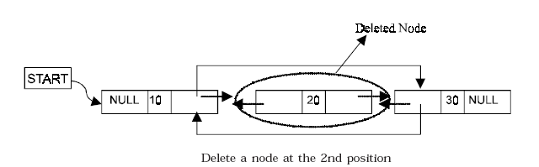

Suppose START is the address of the first node in the linked list. Let POS is the position of the node to be deleted. TEMP is the temporary pointer to hold the address of the node. After deletion, DATA will contain the information on the deleted node.

1. Input the DATA.
2. Initialize TEMP = START; i = 1
3. Repeat the step 4 if (TEMP→DATA !=DATA) and (TEMP != NULL)
4. TEMP = TEMP → RPoint; i = i +1
5. If (TEMP not equal to NULL) and (TEMP→DATA !=DATA)
(a) (TEMP → LPoint) → RPoint = TEMP → RPoint
(e) (TEMP → RPoint) → LPoint = TEMP → LPoint
(c ) Set free the node TEMP, which is deleted
Otherwise
(a) Display “DATA NOT found”
7. Exit

- ALGORITHM FOR SEARCHING A NODE FROM DOUBLY LINKED LIST

Suppose START is the address of the first node in the linked list and DATA is the information to be searched. After searching, if the DATA is found, POS will contain the corresponding position in the list.

1. Input the DATA.
2. Initialize TEMP = START
3. Repeat the step 4, 5 and 6 until (TEMP is equal to NULL)
4. If (TEMP → DATA is equal to DATA)
(a) Display “The data is found at POS”
(b) Exit
5. TEMP = TEMP → RPoint
6. POS = POS+1
7. If (TEMP is equal to NULL)
(a) Display “The data is not found in the list”
8. Exit

- ALGORITHM FOR DISPLAY ALL NODES OF DOUBLY LINKED LIST

Suppose START is the address of the first node in the linked list. Following algorithm will visit all nodes from the START node to the end.

1. If (START is equal to NULL)
(a) Display “The list is Empty”
(b) Exit
2. Initialize TEMP = START
3. Repeat the step 4 and 5 until (TEMP == NULL )
4. Display “TEMP → DATA”
5. TEMP = TEMP → RPoint
6. Exit

- CIRCULAR LINKED LIST

A circular linked list is one, which has no beginning and no end. A singly linked list can be made a circular linked list by simply storing the address of the very first node in the linked field of the last node. A circular linked list is shown in following Figure.
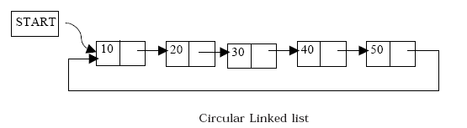

A circular doubly linked list has both the successor pointer and predecessor pointer in circular manner as shown in the following Figure.

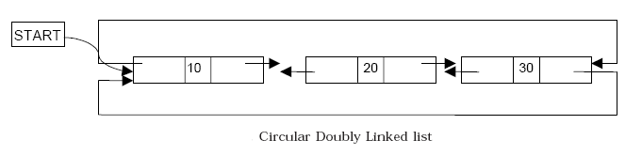

- ALGORITHM FOR INSERTING A NODE IN SINGLY CIRCULAR LINKED LIST

Suppose START is the first position in linked list. Let DATA be the element to be inserted in the new node. POS is the position where the new node is to be inserted. TEMP is a temporary pointer to hold the node address.

1. Input DATA to be inserted
2. Create a NewNode
i.e. NewNode=( struct node * ) malloc ( sizeof ( struct node ) )
3. If NewNode is null then
Print “ Memory is insufficient “
Exit
Otherwise goto 4.
4. NewNode → DATA = DATA
5. If (SATRT equal to NULL)
(a) START = NewNode

Otherwise
(a) TEMP = START
(b) While (TEMP → Next not equal to START)
(i) TEMP = TEMP → Next
(c) TEMP → Next = NewNode
6. NewNode → Next = START
7. Exit

- ALGORITHM FOR DELETING A NODE FROM SINGLY CIRCULAR LINKED LIST

Suppose START is the first position in linked list. Let DATA be the element to be deleted. TEMP,TEMP1 HOLD is a temporary pointer to hold the node address.

1. Input the DATA to be deleted
2. if ((START → DATA) is equal to DATA)
(a) Initialize TEMP = START; TEMP1=START;
(b) While (TEMP → Next not equal to START)
(i) TEMP = TEMP → Next
(c) START = START → Next
(d) TEMP → Next = START
(e)Set free the node TEMP1, which is deleted
(f) Exit
3. HOLD = START
4. while ((HOLD → Next → Next) not equal to START))
(a) if ((HOLD → NEXT → DATA) equal to DATA)
(i) TEMP = HOLD → Next
(ii) HOLD → Next = TEMP → Next
(iii) Set free the node TEMP, which is deleted
(iv) Exit
(b) HOLD = HOLD → Next
5. if ((HOLD → next → DATA) == DATA)
(a) TEMP = HOLD → Next
(b) Set free the node TEMP, which is deleted
(c) HOLD → Next = START
(d) Exit
6. Disply “DATA not found”
7. Exit

STACK
- What is stack? Explain stack with example. Write an algorithm for
following stack operations. OR Explain following stack operations using
suitable example.
  - push( ) [Insertion]
  - pop( ) [Deletion]
  - peep( ) [Extract Information]
  - update( ) or change( ) [Update Information]

Ans.
“ A stack is an ordered collection of homogeneous data elements where the insertion and deletion operation occurs at one end only, called top of the stack ”
OR
“ A stack is a linear data structure in which addition of new element or deletion of an existing element always takes place at the same end, this end is often known as top of stack ”

This situation can be compared to a stack of plates in a cafeteria where every new plate added to the stack is added at top, similarly, every new plate taken off the stack is also from the top of the stack. The two changes that can be made to a stack are given special names. When item is added to a stack, the operation is called push, and when item removed from the stack the operation is called pop. Stack is also called as last-in-first-out (LIFO) list.
If the elements are added continuously to the stack it grows at one end. As shown in following figure.

 |  |  |  |  |  |  |  |  |  | 13 | ← Top
 |  |  |  |  |  |  |  | 7 | ← Top | 7
 |  |  |  |  |  | 11 | ← Top | 11 |  | 11
 |  |  |  | 8 | ← Top | 8 |  | 8 |  | 8
Top=NULL |  | - 4 | ← Top | -4 |  | -4 |  | -4 |  | -4
 |  | 2 |  | 2 |  | 2 |  | 2 |  | 2

-: Pictorial representation of a stack after inserting elements :-

On deletion of elements the stack shrinks at the same end, as the elements at the top get remove as shown below

13 | ← Top
7 |  | 7 | ← Top
11 |  | 11 |  | 11 | ← Top
8 |  | 8 |  | 8 |  | 8 | ← Top
-4 |  | -4 |  | -4 |  | -4 |  | -4 | ← Top | Top=NULL
2 |  | 2 |  | 2 |  | 2 |  | 2
-: Pictorial representation of a stack after deletion of elements :-

Algorithm for push operation :-

Suppose STACK[SIZE] is a one dimensional array for implementing the stack, which will hold the data items. TOP is the pointer that points to the top most element of the stack. Let DATA is the data item to be pushed.

Step 1. If TOP = SIZE – 1, then:
(a) Display “The stack is in overflow condition”
(b) Exit
Step 2. TOP = TOP + 1
Step 3. STACK [TOP] = ITEM
Step 4. Exit

Algorithm for pop operation :-

Suppose STACK[SIZE] is a one dimensional array for implementing the stack, which will hold the data items. TOP is the pointer that points to the top most element of the stack. DATA is the popped (or deleted) data item from the top of the stack.

Step 1. If TOP < 0, then
(a) Display “The Stack is empty”
(b) Exit
Step 2. Else remove the Top most element
Step 3. DATA = STACK[TOP]
Step 4. TOP = TOP – 1
Step 5. Exit

The Peep operation :-
If one interested only about an information stored at some location in a stack then peep operation is required. In this operation we simply move the pointer to the desire location and then fetch the information associates with that location.
Algorithm for peep operation :-
Suppose STACK[SIZE] is a one dimensional array for implementing the stack, which will hold the data items. TOP and TEMPTOP is the pointer that points to the top most element of the stack. LOC is the location for extraction of data.
Step 1. If TOP < 0 , then
(a) Display “The Stack is empty”
(b) Exit
Step 2. Accept LOC
Step 3. If TOP < LOC, then
(a) Display “The Location not found”
(b) Exit
Step 4. TEMPTOP=TOP
Step 5. If LOC = TEMPTOP
Return STACK[TEMPTOP]
Else
(a)TEMPTOP = TEMPTOP – 1
(b)Repeat Step 5.
Step 6. Exit

The Update operation :-
Update operation is required when the content of the some location in a stack is to be changed. Suppose one wants to update information at the i^{th} location from the top of the stack and input the new value of the location .

Algorithm for update operation :-
Suppose STACK[SIZE] is a one dimensional array for implementing the stack, which will hold the data items. TOP and TEMPTOP is the pointer that points to the top most element of the stack. LOC is the location and DATA is the data item for update the data of LOC location.

Step 1. If TOP < 0 , then
(a) Display “The Stack is empty”
(b) Exit
Step 2. Accept LOC and DATA
Step 3. If TOP < LOC, then
(a) Display “The Location not found”
(b) Exit
Step 4. TEMPTOP=TOP
Step 5. If LOC = TEMPTOP
STACK[TEMPTOP]=DATA
Else
(a)TEMPTOP = TEMPTOP – 1
(b)Repeat Step 5.
Step 6. Exit

